OO Analysis and Design Lab Week 2

## Name : Robert Gabriel

Class : Web Development 2

# Q1 Please refer to the Public University Registration System Problem Statement below and answer the given questions

### ( i ) Identify the additional events to which the automated system must now respond.

* A class list is printed for that student. It shows the classes in which the student has enrolled.
* Containing a list of the student’s names and identifiers, is printed for the professor teaching each class
* The Records office keeps a permanent record of the grades and produces a student grade report, which is emailed to each student, and an instructor’s grade report.
* Students request the classes they would like to take, using a touch tone telephone.

### ( ii ) Modify the event table below to incorporate these events. Imagine that each system input associated with an event arrives individually.

|  |  |  |  |  |  |
| --- | --- | --- | --- | --- | --- |
| **Event Number** | Event Description | System Input | Actor Providing Input | System Output | Actor Receiving |
| 1 | Department submits class schedule | Department Class Schedule | Department |  |  |
| 2 | Time to produce class schedule |  |  | University Class Schedule | Student Department Professor |
| 3 | Student registers for Classes | Registration request | Student | Student class list | Student |
| 4 | Time to produce class roster |  |  | Class Roster | Professor |
| 5 | Produces an instructor/student’s grade report | Grades and Reports. | instrcutor | Email with report. | Students and Instructors |
| 6 | Submit Grades | Grades | Department / Staff |  | Students and staff. |

### ( iii ) List other events which might be included in a University Registration system of extended scope.

* Student change his class.
* Submit Grades
* Student may appeal grades given

### ( iv ) Modify Use Case diagram to incorporate additional requirements

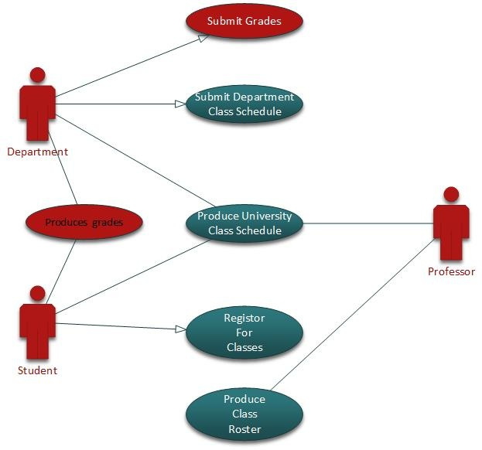

### ( v )Prepare a use case narrative for the additional events in the Public Registration system.

|  |  |
| --- | --- |
| Use Case : | Submit Grades |
| Actors : | Department, Students/Professors |
| Overview : | One week after the examination period instructors submit a grade sheet containing the grades students have earned in each class.  So that the students can access and see there grades. |
| Type : | Essential |
| Preconditions | Student is known by the system.  Has exams. |
| Post conditions: | Online portal is up.  That the results have been posted correctly |
| Special Requirements: | Students must have taken the exam. |

Flow of Events

|  |  |
| --- | --- |
| Actor Action | System Response |
| 1 Use case starts when instructor wants to submit grade sheet |  |
| 2 Instructor provides a grade sheet | 3 Records grades if the date is not there |
|  |  |
|  |  |

Alternative Flow of Events

|  |
| --- |
| Line 3 : Grade sheet is overdue. error. |

|  |  |
| --- | --- |
| Use Case : | Produces an instructor/student’s grade report |
| Actors : | Students and Instructors |
| Overview : | The Records office keeps a permanent record of the grades and produces a student grade report , which is emailed to each student , and an instructor’s grade report, which is distributed to each faculty member. |
| Type : | Essential |
| Preconditions | Emails , have to be on the system. Grades must be graded |
| Post conditions: | Be able to response to other back emails. |
| Special Requirements: | Students must have taken the exam. Send email |

Flow of Events

|  |  |
| --- | --- |
| Actor Action | System Response |
| 1 : Use case starts when records office starts to produce grade reports | 2 : Produces grade reports |
| 3 : On report arrival office emails reports to students | 4 : Sends emails to students |
|  |  |
|  |  |

Alternative Flow of Events

|  |
| --- |
| Line 4 : Invalid email. Retry step 3. |

# Q2 Modify the use case narrative for Register for Classes to require that the system check prerequisites before adding a student to a class

# Q3 Draw a system sequence diagram for the typical flow of events for the use case Submit Department Class schedule.

# Q4 Draw a system sequence diagram for the use case Check out library Book shown in figures below.